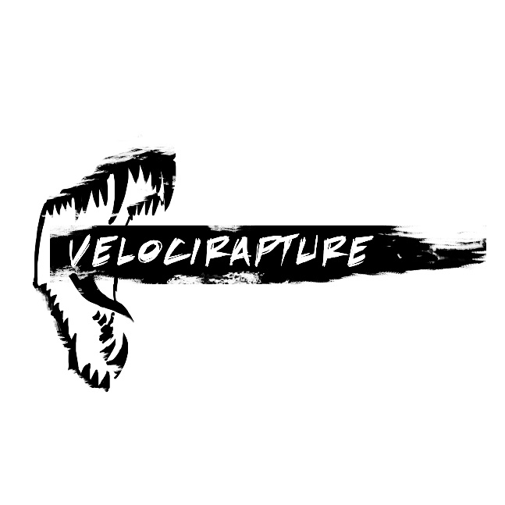

Mid-Sprint Review Sprint Plan
  - Jurassic Sharks
  - Version 1.0
Position Title | Name | Signature
Producer | Max Krembs
Game Designer | Alex Foures
Lead Level Designer | James Pickett
Level Designer | Sam Pate
Lead Artist | Mace Mulleady
Artist | Ashton Maltie IV
Lead Programmer | Taylor Bishop
Programmer | Alex Baird

Team Priorities for Mid-Sprint Review: Friday, April 1 – Thursday, April 14
Priority Order | Priority Title | Description
1 | Environmental Meshes, Textures, and Lighting for Vertical Slice | The team’s first priority for this sprint is to mobilize to finish the Vertical Slice. This work includes sculpting out existing environmental models to give them more detail, creating additional décor and clutter pieces including trim for walls and floors, and a solid pass on environmental lighting and post processing. The team plans to finish this priority item by Thursday, April 7th.
2 | HUD Revisions | The team gathered feedback on the HUD design and has created a new plan to create a clear HUD that conveys all necessary information to players, including their health, armor, ally/enemy team, equipped weapon, and ammo. The team plans to gather feedback on the revised HUD after implementing it, and iterate as necessary. The team plans to finalize this HUD by the end of this sprint.
3 | Clutter Meshes and Textures | This priority item includes all clutter meshes not involved in the Vertical Slice area, and textures for those meshes. We define “clutter” in this context as the modeled assets that minimally affect gameplay, but provide elements of visual interest to the levels.
4 | Environmental Decals | These environmental decals include visual elements that apply to walls and floors to break up textures, such as cracks in stone floors or smoke stains on walls. This priority refers to those decals not involved in the Vertical Slice area.
5 | Non-Vertical Slice Environmental Meshes, Textures, and Lighting | The team then plans to focus effort on bringing all remaining elements of the Raptordome (CTF level) up to at least a first, ideally a second, pass of visual polish. This work includes creating the remainder of environmental meshes necessary, texturing those meshes, and filling out lighting in response to those meshes and textures across the level.
6 | Elements of Player Context | This priority item includes various systematic and HUD elements that give the player a better understanding of the game around them and their place in it. It includes creating functionality for player score and the in-game score screen, player username functionality, and kill camera/spectator mode.
7 | Particle Rework | The particles contained in this priority are those that are included in the environment, such as dust in the air or fire in the braziers. It also includes work on base particles that the team plans to build on for specific applications.
8 | Pickup and Projectile Meshes, Textures, and Particles | This priority contains all pickups, such as armor, health, weapons, and the flag; as well as the projectiles used in the Freeze Gun and Fusion Cannon. The team plans to only bring work on this priority if the remainder of the Raptordome environment is at least a first pass.
9 | Weapon Balance | The team plans to finalize all functionality and balance for their weapons by the end of this sprint.
10 | Player Sound Effects | This priority contains sound effects that involve the player character, including footsteps, and contextual voiceovers (“I’ve got your flag!” etc.).

Dependencies
The below flowchart outlines this sprint’s task dependencies as the team sees them. The team’s first priority is to iterate on the vertical slice so bring it up to final quality (1). From there, the art team then can spread their tasks to creating clutter for designers to work with and incorporate into their levels (2), environmental decals to add variation to the levels (3), and other environmental meshes and textures (5). The team does not expect to achieve final quality with the remainder of the environment for this sprint, but they do plan to achieve at least a first pass, preferably a second, across the whole environment. Implementation of the new HUD (4) is required for the vertical slice revision, and the programming team leads both HUD implementation and the elements of player context (6). Thus, before work continues on any elements of player context, the team plans to dedicate programming time toward the HUD. The team does not see any particular dependency between priorities 7-10.

Mid-Sprint Review Deliverable Description
The team plans to include the following elements in the Mid-Sprint Review deliverable.
- A revised vertical slice for Velocirapture by Thursday, April 7th, including a revised HUD.
- A full vanilla CTF level that contains at least first pass art throughout the entire environment.
- Balanced gameplay functionality.
- Balanced weapon functionality.
- A player scoring system and in-game menu infrastructure.

Stakeholder Feedback Assessment – From Previous Sprint
Priority Order | Feedback Summary | Action Plan
1 | The environment is not up to vertical slice quality. It feels flat, as if the majority of meshes are textured BSP, and the scene needs a lighting pass.  The stakeholders need to see additional/revised environmental pieces to convey the intended quality of the game. | The team agrees, and plans to dedicate a portion of the next sprint to finish elevating the vertical slice area to completion. The team plans to take the pillars as inspiration for the rest of the environment and “chip off” pieces of the stone walls to make the environment feel more organic. The team plans to add trim to walls and floors to break up the visual picture, and add additional meshes, decals, and clutter to convey the arena setting and reinforce the pre-historic themes. In brainstorming various clutter and detail elements, the team plans to focus on the specific story behind each object, and its relation to the two player clans. The team also plans to rework the post processing and lighting to bring the tone of the scene in line with concept imagery.  In terms of planning, the artists are in discussions with the designers to ensure that the artists know the how much leeway that they have in order to embellish the overall look with minimal effect on gameplay.
2 | There are issues with the HUD in general, in particular with the conveyance of armor, the font, the player’s current team. Elements of the HUD also need scale adjustments. | The team agrees that the HUD requires some iteration. The team is not satisfied with the current armor design on top of the health, and plans to experiment with additional methods of conveyance, in particular the circular health design suggested by Prof. Skinner.  The team plans to continue research into font, and attempt to find a new font that players can easily read.  The team also plans to incorporate the player color into additional places in the HUD, reinforcing their team color at every logical opportunity.  In addition to scale, the team also plans to focus on simplifying the HUD.  The team plans to gather feedback throughout the sprint, and continue to iterate based on information gathered.
3 | There are issues of scale in the environmental assets. Most assets dwarf the player. This scale problem is exacerbated in several instances, walls in particular, due to the large surface over which the texture is applied. | The team agrees that realistically-sized objects need to be brought down in scale, including the brazier and the flag itself. However, the team does not want to scale down larger landmark pieces, as they enjoy the imposing atmosphere they provide.  The team has several ideas for how to improve texture use within the Unreal Editor, including tiling textures on the walls, and breaking up larger meshes into smaller pieces using trim or clutter elements.
4 | The flag looks odd when entering the flag room head on—it faces its narrow side to the player. | The team agrees, and plans to rotate the flag to a 45 degree angle of its current position in order to make it clear from all sides what it is. Additionally, the team plans to research making the flag mesh more cloth-like, in an effort to further improve the conveyance of what the flag is.
5 | The character models are not quite interacting correctly with the weapon models. | The team agrees, and knows how to reposition the weapon mesh to remedy this concern. The team also experienced issues with the first person arms, and is strongly considering cutting the first person arms for the sake of time. The team plans to deal with these issues in the upcoming sprint, but they are lower priority concerns than the environmental issues listed above.

